Module 3: CloudWatch Alarms
Assignment
CloudWatch-Alarms-Assignment-–-5
Problem Statement:
You work for XYZ Corporation. To maintain the security of the AWS account and
the resources you have been asked to implement a solution that can help easily
recognize and monitor the different users. Also, you will be monitoring the
machines created by these users for any errors or misconfigurations.
Tasks To Be Performed:
1. Create a CloudWatch billing alarm which goes off when the estimated
charges go above $500.
2. Create a CloudWatch alarm which goes off to an Alarm state when the
CPU utilization of an EC2 instance goes above 65%. Also add an SNS
topic so that it notifies the person when the threshold is crossed.

Task1.
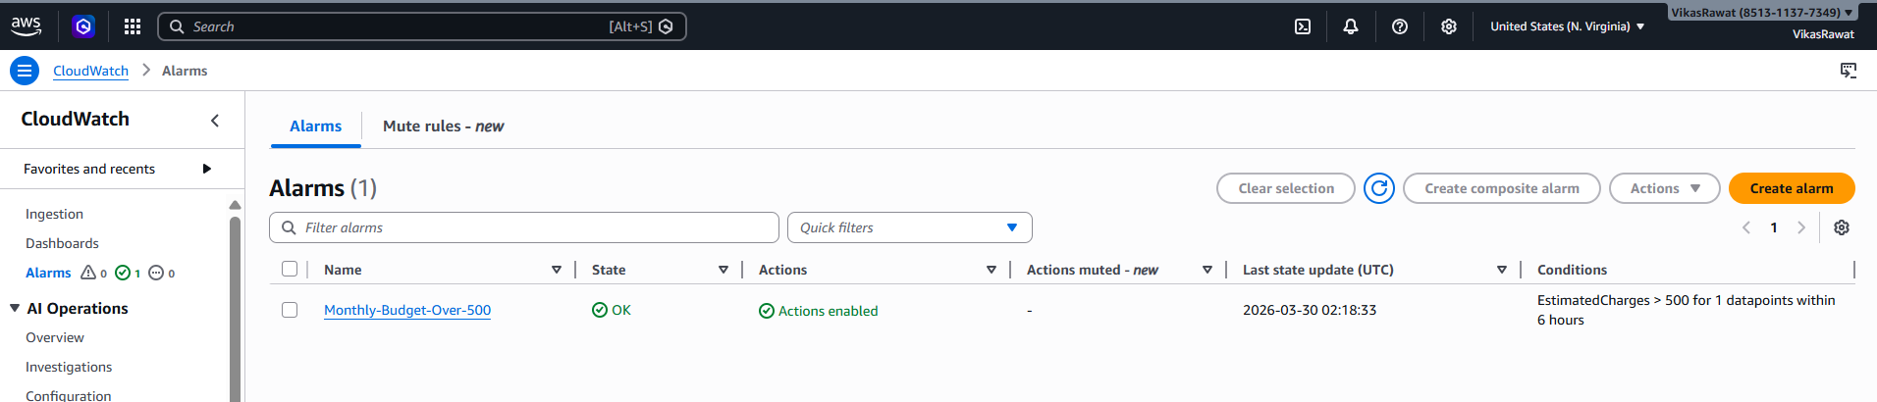
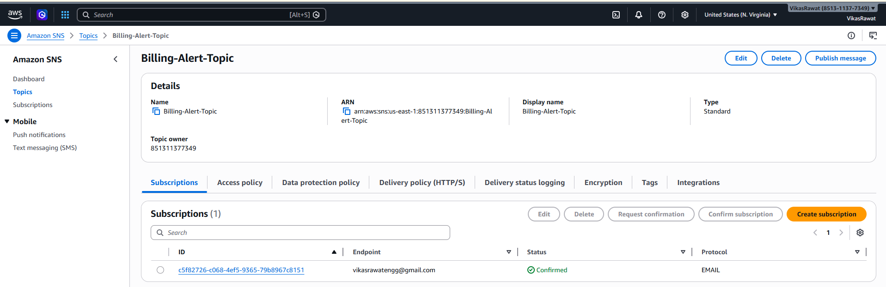
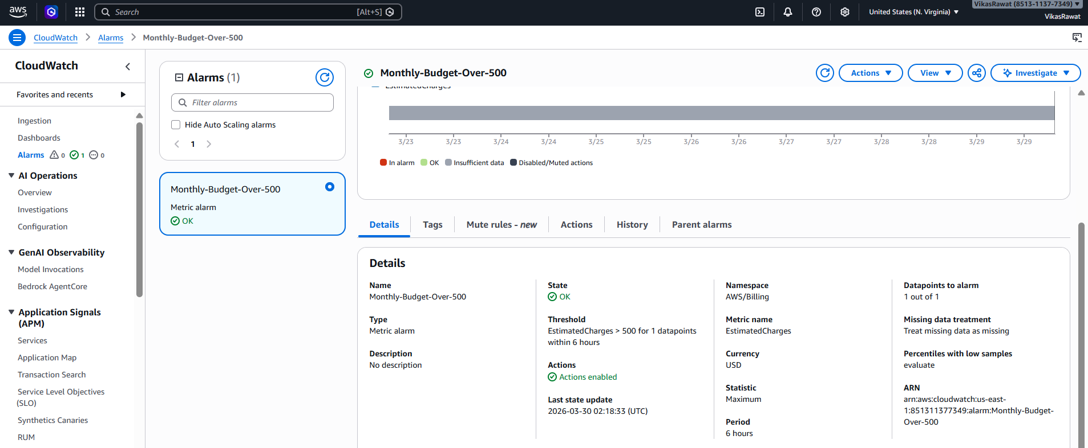

Task2:
